Prepared By – Dilip/Firdos
Date – 18.11.22
Overview – Having the Training Checklist on the iTEAs platform.
Business Requirement:
New Enhancement request for iteas platform for daily training checklist
- Drop down or filter for selecting checklist (Date, session time, course name, trainer, training manager)
- Can view more trainers in the training calendar page
- Edit option should be enabled to update already submitted training checklist for the same day.
- Checklist option which was saved and submitted on day one should automatically replicate in the next day of the training so that Training Ops team doesn’t have to fill the same question again.
- If someone from the training ops is editing a already submitted checklist they should be able to update the comments(mandatory) with a reason for editing the checklist with the name of the user who have updated the comments like the below ref

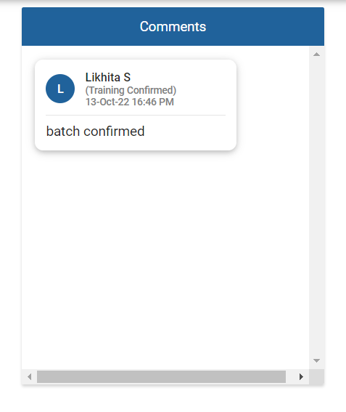
- Option to cancel a training checklist incase the training is getting cancel before the training ends.

